|  |  |  |  |  |  |
| --- | --- | --- | --- | --- | --- |
| MEMO | | | | |  |
| To: | Hunter and Central Coast Regional Planning Panel | | | | |
| From: | Glen Mathews – Senior Development Planner | | | | |
| File: | DA/1166/2020 | **Reference:** | **PPSHCC-53** | Date: | 27 November 2020 |
| Subject: | Current and future strategic context of Pasminco lands, and relationship to Costco application - DA/1166/2020 – Costco | | | | |
|  |  | | | | |

At the determination briefing held on Tuesday 24 November, the Hunter and Central Coast Regional Planning Panel (RPP) requested Council staff provide a memo to the RPP detailing the current and future strategic context of the Pasminco lands and its relationship to the Costco application, and upgrades required to the state road network. This memo responds to this request.

**Development intention of Fotheringham Road**

The current Pasminco Area Plan identifies an intention to provide a link from Main Road, Boolaroo through to the Pasminco site, to Munibung Road on the north eastern side of the containment cell, shown as a combination of primary and local road links in Figure 1.

Council are currently preparing a draft amendment to the Pasminco Area Plan. It is anticipated the draft will be exhibited early in 2021. Council’s Integrated Planning have advised Fotheringham Road will be extended to Munibung Road.

Under the current and future Area Plan, Fotheringham Road will become a collector road and will assist in stimulating the precinct by providing a linkage between future residential and employment lands.

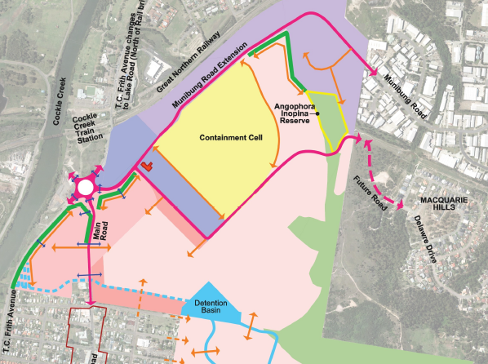

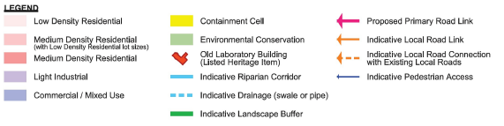

**Figure 1 - Urban Structure Plan - Pasminco Area Plan**

Council are currently assessing two subdivision applications for development of residential land to the south and east of the site (DA/1522/2020 and DA/1525/2020; lodged September 2020). These applications demonstrate a road layout extending Fotheringham Road through to Munibung Road (demonstrated in Figure 2 below) consistent with this strategic intention and the draft Area Plan.

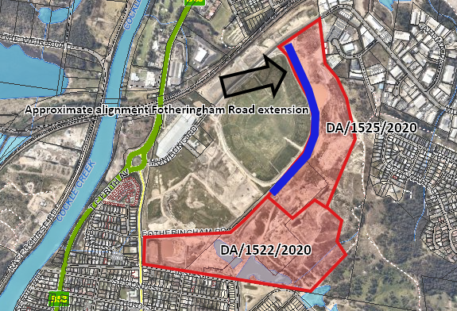

**Figure 2 - Approximate location of residential subdivisions development applications**

**Access to Fotheringham Road**

To ensure adequate capacity remains in the local and state road network once the precinct is fully developed, secondary access from B4 and B7 zoned sites to Fotheringham Road is necessary.

As part of the draft Area Plan, Council is currently investigating additional opportunities for secondary accesses from B4 and B7 zoned sites to Fotheringham Road.

Council have also identified the importance of secondary access to the Fotheringham Road frontage of business zoned lands to encourage activation, active and passive surveillance of the frontage, and ensuring developments are accountable for this frontage. With access being provided to this frontage, the occupant will be compelled to maintain this streetscape to a higher standard given it acts as a customer entry to the development.

The Costco application proposes such an access, thus providing an opportunity to ease pressure on the local and state road network in the future, and ensure this frontage is maintained with a quality landscaping outcome.

Upon Fotheringham Road becoming operable, access from the Costco site to Fotheringham Road will be provided. In the interim, the access from Costco to Fotheringham Road will remain closed and secured with jersey barriers.

Note, Fotheringham Road is intended to cater for residential traffic, and not for service vehicle access. All service vehicles associated with the Costco development will be provided from the approved road to be constructed along the north west boundary of the site (formally identified as Cressy Road).

**Traffic upgrades**

As detailed in the assessment report, and draft conditions of consent the development triggers upgrades to the State and local road network.

The road upgrades required to be in place for operation include a signalised intersection at Munibung Road opposite the Bunnings entrance/exit, a roundabout at the connection between Cressy and Hague Roads, and restriction of access between Hague and Munibung Roads to left in / left out.

Cressy Road and associated upgrades including signalised intersection at Munibung Road are being constructed by the Hunter and Central Coast Development Corporation (HCCDC), which is a development arm of the NSW State Government. Works are being carried out under Division 17 Roads and Traffic, of *State Environmental Planning Policy (Infrastructure) 2007* (Infrastructure SEPP). The Infrastructure SEPP permits HCCDC as a public authority to carry out defined infrastructure works without consent (subject to meeting preconditions).

A Review of Environmental Factors (REF) has been complete by EPS on behalf of HCCDC which has determined all associated upgrades can be carried out as exempt works under the Infrastructure SEPP.

A Section 138 Roads Act approval has been initiated with Council to ensure that all roads and works being constructed are to Council standard. This application is currently being assessed by Council Staff.

A Works Authorisation Deed (WAD) has been initiated with TfNSW for the signalised intersection at Munibung and Cressy Roads.

In addition to these works there is also the requirement for the upgrade of Myall Road and Munibung Road intersection at Cardiff. This intersection currently fails and is part of upgrades required to the wider road network to facilitate the Pasminco precinct redevelopment. Conditions have been included for the Costco development requiring arrangements to be in place with Transport for New South Wales (TfNSW) prior to operation of the development. This will ensure Costco appropriately contributes to these upgrades.



Glen Mathews

Development Planner

Development Assessment and Certification